Name: Mariam Alabi

Course Name: CIS 4374

Instructor: Professor Dobretsberger

Date: 9/10/26

Homework 1

Task 1:

Research: What already exists? Add the existing software landscape to your document, and how your application will be different from what already exists

My response:

A parking app that already exists is the ParkMobile app. The ParkMobile app allows a driver to find and pay for parking on the app. While looking at the app, I noticed that a driver only has access to the location of where they want to park, but not the parking spot when they have arrived at their destination. I believe that my application will be better from the Parkmobile app because my application will allow drivers to reserve a particular parking spot for when the driver arrives.

Task 2:

Start vision and scope section: Start with how the this project was acquired introduction of your (fictional company, and rough overview of what this project is about

My response:

The Smart Parking Platform was acquired after identifying the needs of finding parking for the drivers. The key goal of this project is to satisfy the users that are in need of finding available parking, reserve parking spots, and paying for the parking space. This project will also benefit the parking operators by helping them keep track of the amount of parking spaces being used.

Task 3:

Deliver a draft for the SRS, including 15 user stories (minimum). This should grow over the course of the semester to completion.

- User registration and authentication

Actor: Driver
Purpose: The driver needs to create an account before reserving a parking spot.
Steps:

- The driver would need to create an account to log into the app (email, password, and vehicle information).
- The system would now send a verification code.
- The driver then uses the code to complete registration and log in.

- Real-time parking space availability

Actor: Driver
Purpose: Showing the drivers the available and occupied parking spots

Steps:

- The driver would need to select which parking garage that they would want to go to.
- The app will then check the real-time information from the sensors to see which parking spaces are available or occupied.
- The app will show the driver the available spots that are green and the occupied spots that are red.

- Interactive map displaying available parking locations

Actor: Driver
Purpose: The drivers are provided with a layout of the parking garage

Steps:

- The driver looks in the app to find the parking garage that he/she wants.
- The driver selects which floor level they would like to view
- The app shows where to drive and which parking spaces are available.

- Parking reservation capability

Actor: Driver
Purpose: The drivers are reserving a specific parking spot before arrival

Steps:

- The driver selects an open spot on the floor map.
- The driver clicks on “Reserve Spot.”
- The system sets a 25 minute time period so no other drivers can claim it.

- Digital payment processing

Actor: Driver
Purpose: Allowing the drivers to park for their parking ticket.

Steps:

- The driver opened the payment checkout section
- The driver then selects a payment method
- The system processes the transaction and sends them an email confirmation code.

- Reservation history and receipts

Actor: Driver
Purpose: The driver is able to view past parking history and view past receipts.

Steps:

- The driver clicks on the "Reservation History” tab to review their past transactions.
- The system shows the driver the list of past parking visits.
- The driver can view any past visits and download their receipts.

- Administrative dashboard for parking operators

Actor: Parking Operators
Purpose: Parking Operators are able to manage their parking garage.

Steps:

- The Parking is able to log into the system
- They can select their registered facility
- The system shows all the data for the parking spaces, prices, and other facility utilities.

- Occupancy reporting and analytics

Actor: Parking Operator
Purpose: The parking Operators

Steps:

- The Parking operator views the “Analytics” section on the dashboard.
- The system will now display a chart showing the daily activity.
- The Parking operator can choose to view information at any time period (day, week, month, and year).

- Notifications and alerts for users

Actor: Driver
Purpose: Alerting the drivers on when their parking time is close to expiring.

Steps:

- Once the driver has reserved a parking spot, the system then starts a 25-minute countdown timer for the driver to arrive.
- The system then notifies the driver 25-minutes before the time expires.
- The driver has the option to extend the parking reservation.

- Integration with external mapping/navigation services

Actor: Driver
Purpose: The app provides the driver direction.

Steps:

- On the app the driver clicks on “Navigate” to know where the drivers are heading to.
- The app is then provided with a GPS so that the driver can know where the garage entrances are.
- Once the driver enters the garage, the app will then explain the directions on where to go and find the reserved parking spot

- Dynamic pricing rules/ events

Actor: Parking operator
Purpose: The parking prices increase during busy events

Steps:

- The parking operators when the parking prices increase or decrease
- The system monitors how occupied the parking garage gets during busy hours (busy events).
- The app will show the drivers the updated prices.

- Garage layout of the parking garage

Actor: Parking Operator
Purpose: Creating a layout of the parking garage for the drivers to view.

Steps:

- The operator creates a layout of the parking garage.
- The parking operator creates the levels, lanes, and parking spaces.
- The parking operator then links an overhead sensor to track the parking spots.

- Parking expiration time & session extension

Actor: Driver
Purpose: When the parking expiration is about to expire, the driver extends the reservation time.

Steps:

- The system will notify the driver that their parking time is about to expire.
- The driver has the decision to choose if he/she wants to add more time to the reservation.
- The driver would then need to pay a small fee for extra time.

- Automated exit and digital receipts

Actor: Driver and System
Purpose: The system ends the parking session by giving the driver a receipt and opening the gate.

Steps:

- Once the driver leaves he parking the spot the overhead sensor will turn red
- The system has updated and has kept the spot available.
- The system will give the driver a receipt and open the exit gate for them.

- Filtered reservation for eclectic vehicle

Actor: Driver that owns an electric car
Purpose: Has a filtered layout for where the charging stalls are and allows the drivers to reserve it.

Steps:

- The driver goes to the app and clicks on the “EV Charging” filter tab.
- The app will then show the drivers where the EV charging stalls are located in the parking garage.
- The driver reserved an EV spot.

Name: Mariam Alabi

Course Name: CIS 4374

Instructor: Professor Dobretsberger

Date: 9/17/26

Homework 2

Component 1: Driver’s authentication and security
- Account registration & identity verification for the user
- Build account registration (includes: email, password, vehicle information).
- Send and verify the user’s verification code.
- Secure the user's password and login session.

Component 2: Parking availability and reservation
- Garage mapping & sensors
- Build a real-time overhead sensor (green means the parking spot is available, and red means the spot is taken).
- Display parking availability on each parking layout.
- Provided a filter for electric vehicle (EV) charging parking spots.

- Reservation & parking sessions
- Allow drivers to reserve a parking spot for 25 minutes.
- Provided registration countdown and expiration alerts to notify the driver.
- Allow drivers to extend their reservation for an additional fee.

Component 3: Payment to access official parking & automated gate access
- Payment
- The driver pays with a credit card or any other digital wallet.
- Generate and email the user’s receipts.
- Users are able to view payment history and download their receipts.

- Automated gate access
- Connect an overhead exit sensor to detect when a vehicle leaves.
- The exit gate automatically opens once a driver is done with their session.

Component 4: digital reports/ analytics and dynamic prices
- Digital reports
- Create charts for parking occupancy by day, week, month, and year.
- Allow drivers to view transaction history and download receipts.
- Allowing the operators to download the summary reports of the parking garage revenue.

- Analytics & dynamic prices
- Creating a dashboard to monitor and view parking availability
- The system will automatically change parking prices during busy events.

Task 2: Draft timeline (Including Gantt chart)

Timeline:

Component | Tasks | Start | End | Duration
1- Driver's authentication and security | Build account registration | 9/16/2026 | 9/20/2026 | 5
1.1.1 | Send and verify the user’s verification code | 9/21/2026 | 9/23/2026 | 3
1.1.2 | Secure the user's password and login session | 9/23/2026 | 9/27/2026 | 5
Parking availability & reservation | Build a real-time overhead sensor | 9/28/2026 | 10/3/2026 | 6
1.2.1 | Display parking availability on each parking layout | 10/4/2026 | 10/9/2026 | 6
1.2.2 | Provide a filter for electric vehicle (EV) charging parking spots | 10/10/2026 | 10/14/2026 | 5
1.2.3 | Create 25-minute reservation feature | 10/10/2026 | 10/17/2026 | 8
1.2.4 | Add countdown & expiration alerts | 10/15/2026 | 10/22/2026 | 8
1.2.5 | Add reservation extension fee | 10/23/2026 | 10/26/2026 | 4
Payment & automated gate access | The driver pays with a credit card or any other digital wallet. | 10/25/2026 | 11/4/2026 | 11
1.3.1 | Generate and email the user’s receipts. | 10/25/2026 | 11/4/2026 | 11
1.3.2. | View payment history and download receipts | 11/5/2026 | 11/8/2026 | 4
1.3.3 | Connect overhead exit sensor | 11/9/2026 | 11/12/2026 | 4
1.3.4 | Automatically open exit gate | 11/13/2026 | 11/17/2026 | 5
Digital reports, analytic, and pricing | Create parking occupancy charts | 11/13/2026 | 11/20/2026 | 8
1.4.1 | Add transaction history & receipt downloads | 11/16/2026 | 11/21/2026 | 6
1.4.2 | Create parking garage revenue reports | 11/18/2026 | 11/23/2026 | 6
1.4.3 | Create parking availability dashboard | 11/21/2026 | 11/30/2026 | 10
1.4.4 | Add automatic dynamic pricing | 11/24/2026 | 12/4/2026 | 11

Gantt Chart:

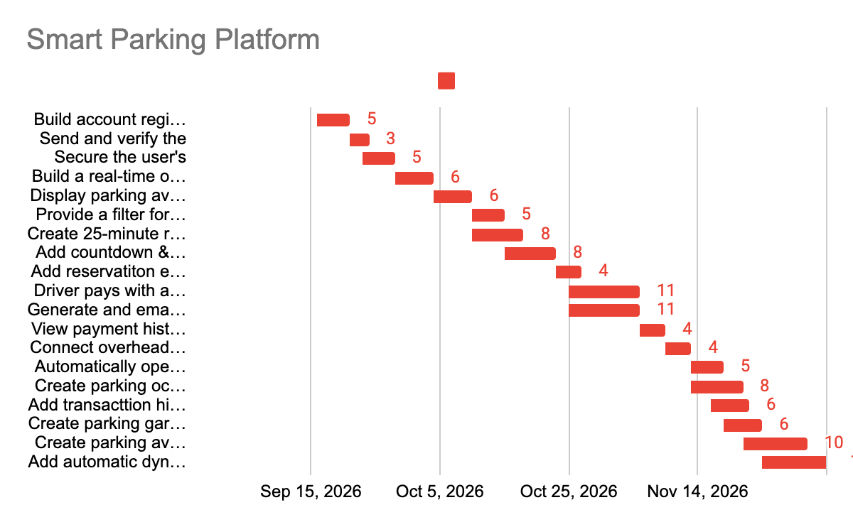

Name: Mariam Alabi

Course Name: CIS 4374

Instructor: Professor Dobretsberger

Date: 9/24/26

Homework 3

- Create backlog for Parking app (full image will be down below)

Link to Trello:
https://trello.com/invite/b/6ab3f5c9b4db69f17012e176/ATTI6c1e8137c64583e16e982ee6955368c95ED3A11B/smart-parking-platform

My screenshot:
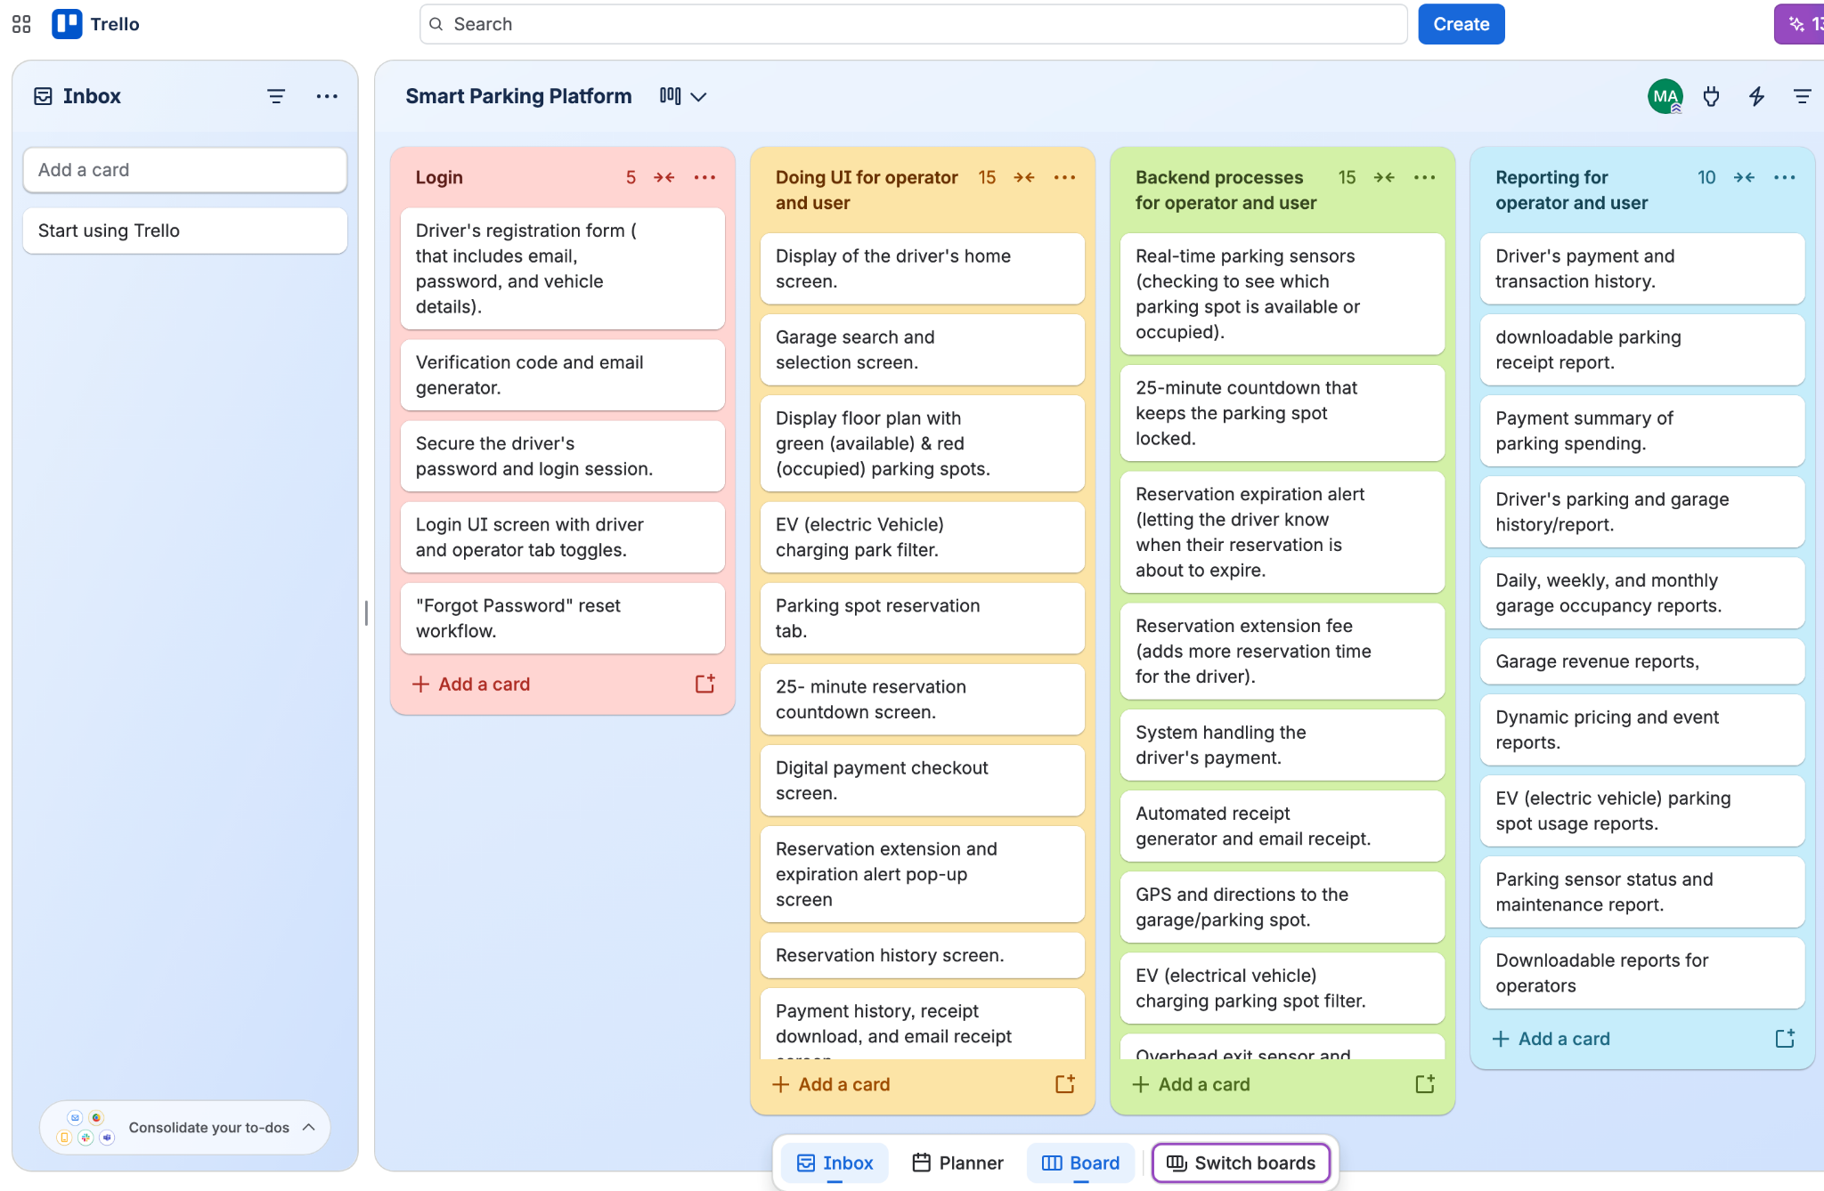
- Plan Sprint 1 backlog: (My screenshot)
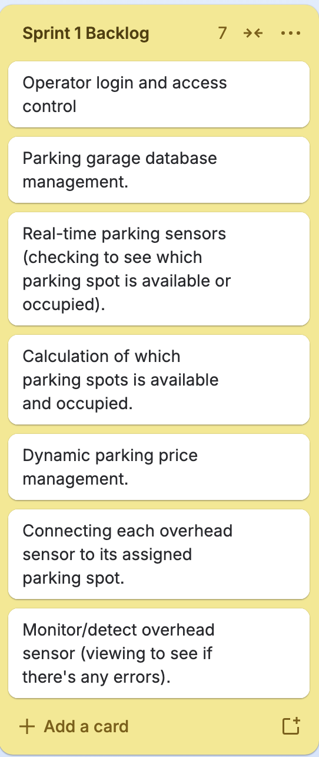

Name: Mariam Alabi

Course Name: CIS 4374

Instructor: Professor Dobretsberger

Date: 10/1/26

Homework 4

- Identify and list at least 4 risks for each category: technical, schedule, financial, people.

Technical Risks:
- A technical risk means that there may be problems or issues with the technology used in a project.
- Parking sensor failure

When the overhead parking sensors may stop working or show the wrong parking post availability.

- Payment system failure

When the payment system may have some issues processing the driver’s credit card or digital wallet.

- GPS Failure

When the GPS system gives the driver the incorrect direction to the garage or any reserved parking spot.

- Automated exit gate failure

When the automated exit gate may fail to open when the driver finishes their parking system. This could cause traffic in the parking garage.

Schedule Risk:
- Schedule risks means that there are delays that may cause the project to take longer

- Reservation Feature Delay

When the 25-minute parking reservation may take longer than expected.

- Overhead sensor and Testing Delay

Building, installing, and testing the real-time overhead parking sensors, which may take longer than planned.

- Payment system delay

When setting up, securing, and testing the driver’s card and digital wallet, the processing system may take a little longer than expected.

- Automatic dynamic pricing development delay

When the dynamic pricing feature may take longer than expected.

Financial Risks:
- Financial risks means that the project may cost more money than planned.

- Parking sensor cost

- When the real-time overhead parking sensor cost more than expected

- Maintenance for parking sensors
- When the broken sensor may cost more money to repair or replace.

- Dynamic Pricing:

When the software error may possibly charge the wrong parking price. This could cause the parking garage to lose money.

- Automated gate cost
Installing and maintaining the automated exit gate may cost more than expected.
People Risk:
- People's risks means that there could be team members that could affect the project.

- Poor communication skills from teams

- When poor communication is built in teammates, this causes teams to misunderstand their tasks.

- Main developer is absent

- When the main developer is absent, the project can cause major delays.

- Team members Quitting

- When a team member may quit, which could possibly lead to delays

- Lack of experience

- When a team member may not have enough experience to complete their tasks correctly.

- Build a Risk Register with at least 10 entires

ID | Description | Probability | Impact | Owner | Response Strategy | Status/ Notes
TR-1 | The parking sensor may stop working or show incorrect parking availability | Moderate | Major | The Technical Team | Mitigate | Need to test the monitors regularly.
TR-2 | The payment issue may have some issues processing credit cards or digital wallet | Low | Major | The Technical Team | Mitigate | Testing the payment system before releasing
TR-3 | The GPS may give drivers incorrect directions to the garage or parking spot. | Low | Moderate | The Technical Team | Mitigate | Testing and regularly checking the GPS and navigation system.
TR-4 | The automated exit gate may fail to open for the driver. | Low | Major | The Technical Team | Mitigate | Testing and maintaining the automated exit gate.
SR-1 | The 25-minute reservation feature may take longer to develop. | Moderate | Moderate | Development  Team | Mitigate | Regularly check the process of making sure that the feature is completed on time.
SR-2 | Building, Installing, and testing overhead sensors may take longer than planned. | Moderate | Moderate | The Project Manager | Mitigate | All sensor installation must be tested early.
FR-1 | The parking sensor may cost more than expected. | Moderate | Moderate | The Parking Manager | Mitigate | Monitor the sensor costs and the project budget.
FR-2 | The broken sensors may cost more money to repair or replace. | Moderate | Moderate | The Parking Operator | Mitigate | Monitor the sensor repair and replacement cost to stay within the project budget.
PR-1 | When poor team communication may cause team members to misunderstand their task. | Moderate | Moderate | Project Manager | Mitigate | Regular checking and having team meetings.
PR-2 | When the main key developer may be absent, causing projects to delay. | Low | Major | Project Manager | Mittigrate | Making sure that other team members understand how to do the developers tasks.

- Create a Communication Plan: meeting cadence per team, reporting methods

Communication Type | Meeting Cadence | Purpose | Reporting Method
Daily Stand-Up | Daily | Discuss the current tasks and issues. | Short meeting with teams.
Progress Meeting | Weekly | Discuss the progress of the project, risk, and upcoming task. | Progress report of the meeting.
Sprint Meeting | Monthly | Review the overall progress of the project/ | Project demonstration and report of it.

